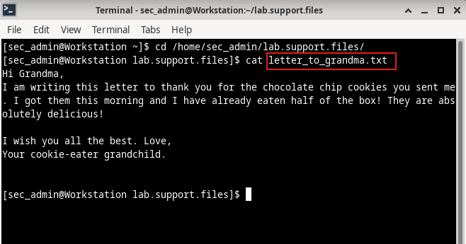
On the security workstation VM, I navigated to /home/sec_admin/lab.support.files to locate the letter_to_grandma.txt file and used the cat command to list its contents.

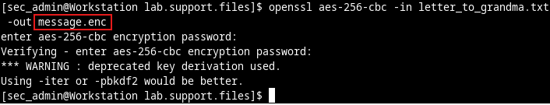
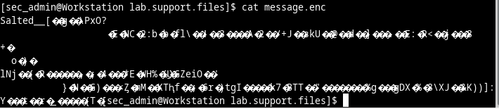
This demonstrates the use of the AES-256-CBC algorithm on OpenSSL to encrypt the letter_to_grandma.txt file and save the encrypted version as message.enc. Now the use of the cat command displays the encrypted contents of the message.enc file.
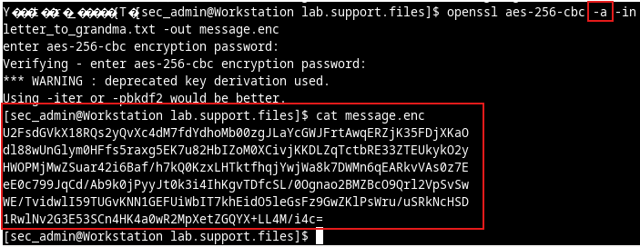
To make the file readable, I added -a on the previous OpenSSL command, which tells OpenSSL to use a different encoding method of base64 (convert binary to text). After that, the cat command displays the contents of the updated version of the message.enc file.

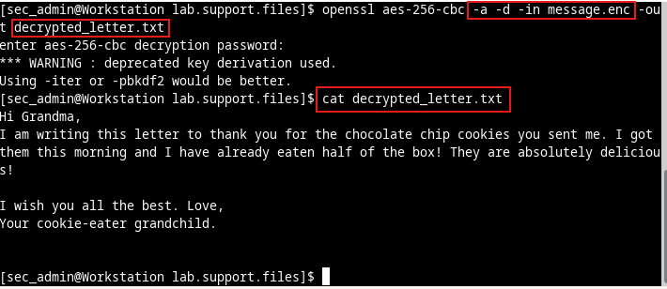
Now, to decrypt the contents of the message.enc file, the same OpenSSL commands have been used with a small change of adding -d and save the decrypted version as decrypted_letter.txt. Now, using the cat command, display the readable contents of the decrypted_letter.txt file.

